Dated 29th April 2024

1. "Static" Website hosting

Create a bucketed as per the S3 Assignment 1

First you have to prepare your html pages >>>> index and error and AWS .png file ( three files )

And upload them into the S3 Bucket .

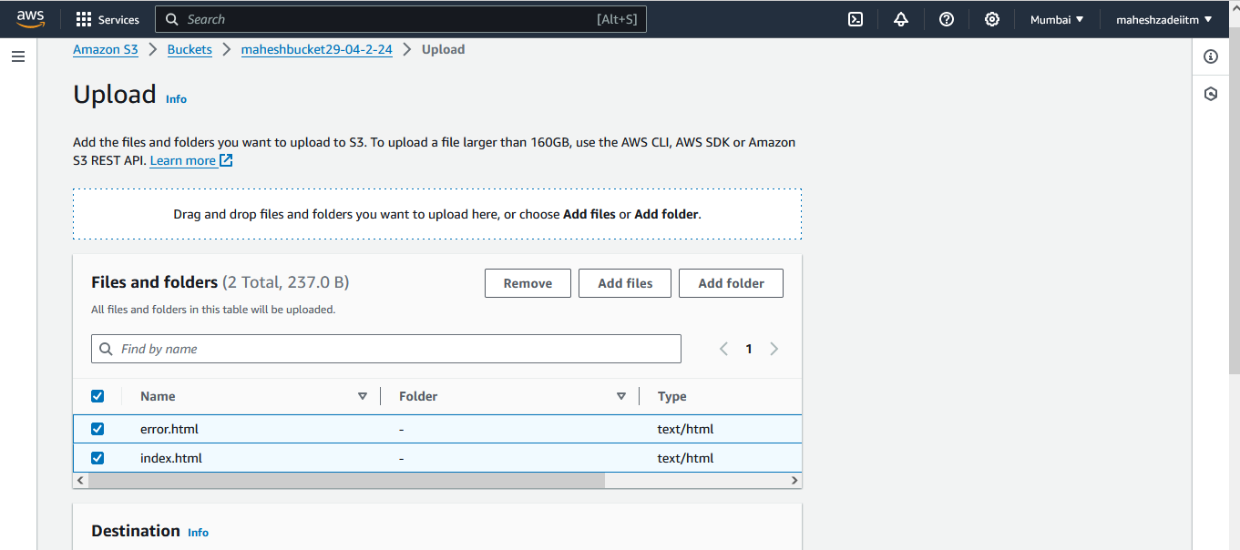

Click on upload

Bucket Properties >>>> Static website hosting >>> Edit >>> Enable

Click on edit

Click on enable

Type index.html and error.html

Now Click on Save changes

Successfully edited static website hosting

Index document >>> index.html

Error document >>>> error.html

Save changes

Click on Make Public

NOw you can see your static website URL is ready

<http://maheshbucket29-04-2-24.s3-website.ap-south-1.amazonaws.com>

Paste in the browser

Then give permissions at the bucket and object level.

COpy your Static website URL and try to access it.

add a lifecycle rule for the bucket:

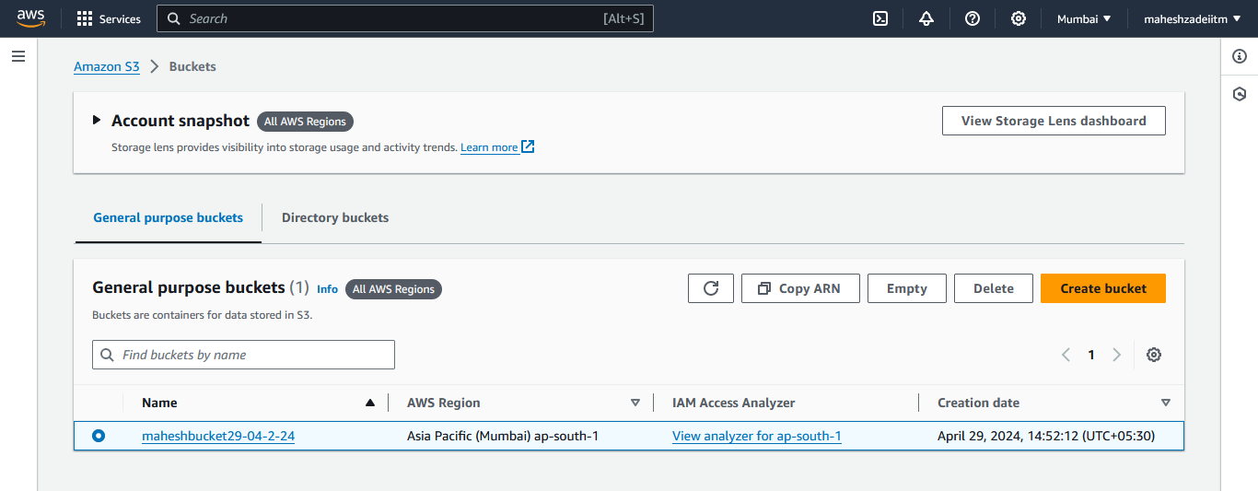

Go to Mangemnet

1. Transition from Standard to Standard-IA in 60 days

1. Expiration in 200 days

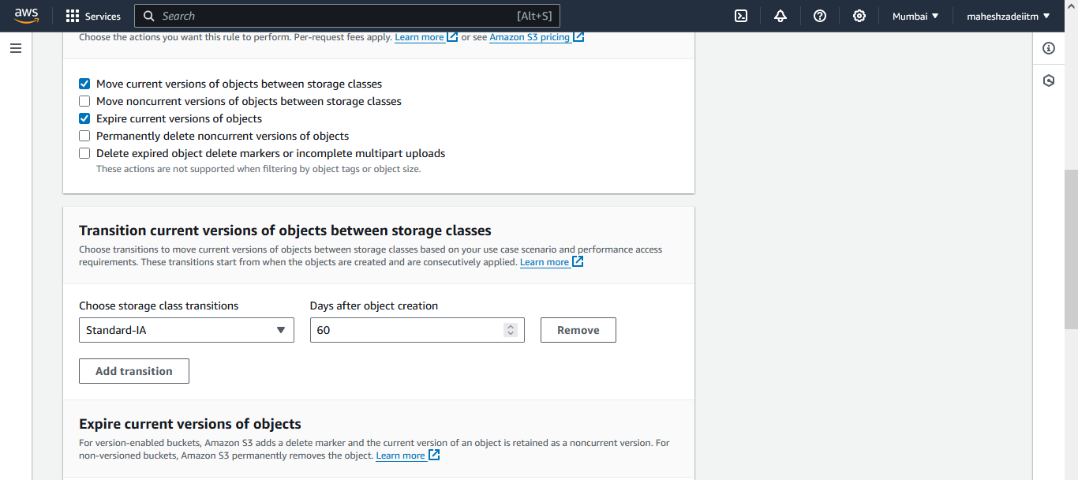

Click on create Rule

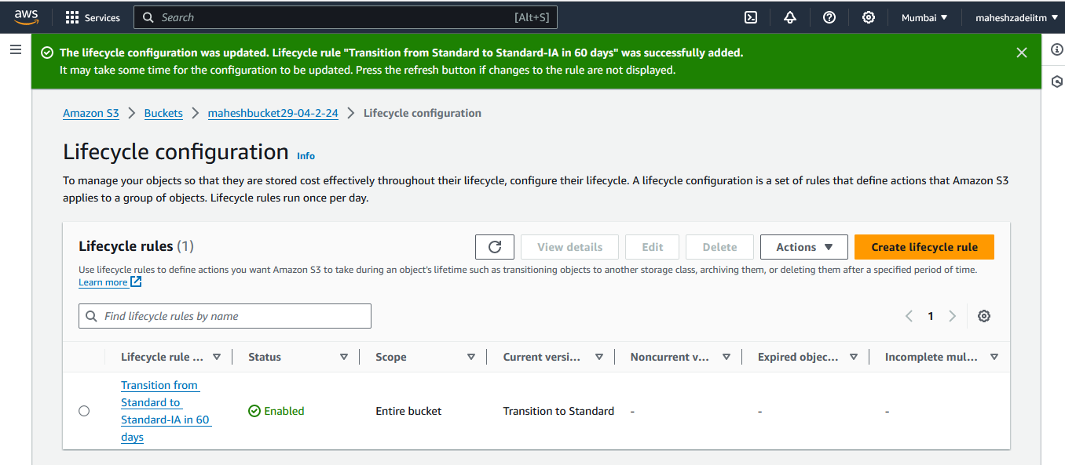

Life Cycle Rule successfully added .

S3 Stactic website hosting Assignmnet completed .

Pls check and confirm .

Thanks